Research Article

Tank-Based Nursery Production of the Sea Cucumber Holothuria scabra in Various Seaweed Feed Regimens

Cristan Joy M. Campo^{1*}, Nonita S. Cabacaba¹, David N. Cosmiano Jr.²
¹National Fisheries Research and Development Institute - Marine Fisheries Research and Development Center
²Bureau of Fisheries and Aquatic Resources - Guiuan Marine Fisheries Development Center, Guiuan, Eastern Samar 6809 Philippines

*Corresponding Author
Email:
Contact number:
ORCID identifier (All authors must have an ORCID identifier. If you haven’t registered yet, please do so through this link https://orcid.org/register)
Tank-Based Nursery Production of the Sea Cucumber Holothuria scabra in Various Seaweed Feed Regimens
Abstract
This study explored the feasibility of Laurencia papillosa, Sargassum spp, and Gracilaria bailinae crude extracts as feeds for the juvenile sea cucumber Holothuria scabra in a tank-based system. Post-metamorphic juveniles (~1 mm) were harvested from larval tanks and were reared until the late juvenile stage in indoor tank systems at 300 ind./tank stocking density for 45 days. Growth and survival rates of H. scabra juveniles were monitored to assess the performance of each seaweed treatment. L. papillosa consistently yielded the best growth (SGR: 7.63-11.32%.d⁻¹) and highest survival rates (54.6–56.8%) of H. scabra juveniles. The performance of L. papillosa did not differ from that of Sargassum spp., while G. bailinae yielded poor growth (SGR of 5.01–9.38%.d⁻¹) and low survivorship of juveniles (8.77–19.77%). Growth and survival rates were similar between fresh and dried seaweeds (p>0.05), suggesting dried seaweeds' applicability as feeds for juvenile H. scabra. Moreover, increased feed rations resulted in better growth of juveniles, but survival rates among feed rations (4.5, 6.0, 7.5, and 9.0 L.d⁻¹) did not differ significantly (p>0.05). The monthly mean water temperature ranged from 26.6°C to 28.8°C, salinity of 33.2–35.1 ppt, dissolved oxygen of 6.1–8.3 mg/L, and pH of 8.1–8.3. High yields of sea cucumber juveniles were observed during the dry season, while low survival rates (<20%) were observed during wet months. The success of this study could set forth the application of tank-based nursery systems for H. scabra, especially during the season of high rainfall and extreme weather conditions that heavily affects cage rearing in the open-sea setting.
Keywords: Gracilaria bailinae, Holothuria scabra, Laurencia papillosa, Sargassum sp., sea cucumber aquaculture, seaweed feeds
1. Introduction
The tropical sea cucumber Holothuria scabra is an important commercial species in the Indo-Pacific region. However it is among the most overexploited holothurians (Uthicke 2004) and one of the seven endangered species on the IUCN Red List for Aspidochirotida (Hamel et al. 2013). According to Choo (2008), overfishing is the main problem contributing to the depletion of sea cucumber resources. They are easily caught since they are commonly found in shallow waters. Other threats to sea cucumber resources include illegal fishing, habitat loss, lack of accurate statistics, global warming, and new uncontrolled uses, such as pharmaceuticals and nutraceuticals.
The development of seed production techniques and release of hatchery-produced juvenile sea cucumbers are currently advocated as one way to rebuild and rehabilitate the wild populations. Moreover, significant efforts are being made toward conserving sea cucumber resources through the imposition of fisheries regulation and production through aquaculture (Choo 2008).
The seed production of H. scabra has been initiated in the Philippines by the University of the Philippines Marine Science Institute (UP MSI) at the Bolinao Marine Laboratory (Gamboa and Juinio-Meñez 2003). The Southeast Asian Fisheries Development Center Aquaculture Department (SEAFDEC-AQD) in Iloilo has also been producing hatchery-reared H. scabra juveniles in net cage nurseries since 2010 for stock enhancement and livelihood programs (SEAFDEC-AQD 2018). This effort was also expanded by the Bureau of Fisheries and Aquatic Resources (BFAR) in Eastern Samar in 2013 (Cabacaba and Campo 2019). Net cage trials in Eastern Samar were successful; however, with a more productive season only during the summer months. Low survivorship was mainly due to extreme weather experiences in the locality; thus, some of their production were conducted in indoor tanks, especially during the wet season (Cabacaba and Campo 2019). Nursery production in tanks requires not only a continuous replenishment of good quality seawater but also supplementation of food to nourish the juveniles, just as the natural environment can provide. In a contained set-up, the feeding regimen should consist of diatom culture, fine starter shrimp pellet, and dried algae or seaweed paste (Agudo 2006; Gamboa et al. 2004).
Seaweeds have been used as food, animal alternative feeds, fertilizer, and sources of traditional medicine in many Asian civilizations since ancient times. The use of seaweeds, even in aquaculture, is not even a new technology (Rajauria 2015). Seaweeds are excellent dietary sources of vitamins and trace minerals. They contain bioactive substances like polysaccharides, proteins, lipids, and polyphenols (Marinho-Soriano et al. 2006). These properties give seaweed great potential as a supplement in functional food or for extracting compounds.
Several studies have investigated the potential of some seaweeds as artificial feed for sea cucumbers. In Indonesia, Caulerpa racemosa (green algae), Cystoseira indica (brown algae), and Jania rubens (red algae) have been tested as feeds in powder form for the sea cucumber H. impatiens. The growth performance of the sea cucumber juveniles was observed best in juveniles fed with the brown algae C. indica compared to C. racemosa and J. rubens. Moreover, the ingestion rate and the ammonia-nitrogen production were lower in sea cucumbers fed with C. indica (Mahmoud et al. 2017). In a Korean study, Sargassum thunbergii, Ulva lactuca, Undaria pinnatifida, Laminaria japonica, Schizochytrium sp., and Nannochloropsis oculata were tested as seaweed feed for sea cucumbers in a recirculating aquaculture system. Survival rates were not significantly different among the seaweed diets, but growth rates were highest when fed with U. lactuca (Anisuzzaman et al. 2017). In China, the feeding preference of Apostichopus japonicus sea cucumbers on different seaweed paste diets was also investigated. Seaweed diets including Sargassum thunbergii, Sargassum polycystum, Zostera marina, Ulva lactuca, and fresh and boiled Laminaria japonica were mixed with mud and inert markers and were fed separately. The study concluded that A. japonicus prefers L. japonica which made up more than 50% of their entire diet (Xia et al. 2012).
Since the pilot testing of hatchery production of H. scabra in the Philippines (Gamboa and Juinio-Meñez 2003), there is no local technology yet that uses seaweeds to optimize growth in tank nurseries. Traditionally, juvenile H. scabra is directly reared in hapa nets in the open sea, where predation and uncontrolled environmental conditions are inevitable. Using an alternative rearing medium such as an indoor tank system could potentially increase the yield of sea cucumber seeds by providing controlled conditions and a setup protected from strong currents and winds. In addition, constraints in nutritional requirements in contained setups, like in tank-based systems, can be overcome by providing seaweeds as feeds. In this study, the practicability of using seaweeds, including Sargassum sp., Laurencia papillosa, and Gracilaria bailinae, as feeds for H. scabra reared in indoor tanks has been assessed.
2. Materials and methods
2.1 Spawning and larval rearing
Batches of wild-caught H. scabra broodstock were collected from the local waters of Guiuan, Eastern Samar, Philippines (11° 1′ 7.7″ N, 125° 42′ 39.4″ E). They were held and maintained in sea pens at the sea cucumber hatchery of the Bureau of Fisheries and Aquatic Resources – Guiuan Marine Fisheries Development Center (BFAR-GMFDC). Spawning trials were scheduled on days of each month’s full or new moon. Healthy broodstock with an average body weight of 255.9 ± 29.3 g (mean ± SD), no observed evisceration, and no skin lesions was selected for spawning. Induced spawning was conducted by following the method of Juinio-Meñez et al. (2012) and Agudo (2006), employing dry treatment, followed by Spirulina bath for 45 minutes each exposure with the omission of thermal shock. Afterward, the animals were placed in spawning tanks with sand-filtered seawater and were allowed to spawn for 1 to 4 hours. Males would usually spawn their sperm as whitish ejaculates earlier, stimulating the females to release their orangy eggs. Eggs and sperms were collected immediately after spawning and were placed in separate tanks. The gametes were then placed together in a 50-L transparent plastic container, and fertilization was allowed to proceed for an hour. Post-fertilization developmental stages of H. scabra were monitored, and egg density was determined via microscopy. Figure 1 shows the hatchery facility of BFAR-GMFDC and the nursery experimental set-up designed for this study.
2.2 Larval rearing
Developing eggs and larvae were reared in 60-L capacity transparent plastic rectangular containers at 30,000 individuals/tank stocking density. Aeration and sand-filtered seawater were provided, and tanks were covered with a black net as shade. Corrugated plastic settlement plates (1 x 1 ft) smeared with Spirulina paste were also provided on Day 10 to induce attachment of pentactula larvae. Replenishment of seawater in the larval rearing tanks was done by siphoning 50% of the amount every other day. The larvae were fed with combined Chaetoceros calcitrans and Chaetoceros gracilis microalgae maintained at 30,000–50,000 cells.mL⁻¹, following the method of Campo et al. (2019). Microalgal concentration was amplified as larvae feed requirement also would increase over time. Larval rearing was conducted for one month until they developed into ~1 mm post-metamorphic or early juveniles. Water quality in larval tanks was maintained at temperature 28.0–31.5°C, salinity of 33–35 ppt, dissolved oxygen of 6.0–8.0 mg.L⁻¹, and pH of 8.0–9.5. Spawning activities and larval rearing were conducted monthly to supply batches of early juveniles for nursery experiments.
2.3 Nursery facility
Indoor tanks with a dimension of 1 m x 1 m x 0.3 m (l x w x h) were installed at the sea cucumber hatchery of BFAR-GMFDC. Tanks were filled with sand-filtered seawater and were provided a flow-through system that maintained a maximum volume of 200 L. An aeration system comprising airstones, air hose, and control valve was also installed in each tank. In addition, spirulina-smeared settlement plates were placed in the tanks to supplement food for the early juveniles, and tanks were covered with a black net for shading. All the experiments conducted in this study followed these mentioned requirements and conditions.
2.4 Seaweed extract diets preparation
The seaweeds used in this study were Laurencia papillosa, Gracilaria bailinae, and Sargassum sp. Figure 2 shows the three seaweeds utilized in this study. These were collected from the nearby local waters of Guiuan, Eastern Samar. The seaweeds were rinsed using seawater to remove unnecessary particles and were cut into bits. Crude extracts were produced via extraction by blending 500 g fresh weight of each seaweed. Afterward, the crude extracts were sieved and were further diluted at 10 g seaweed per liter of seawater. The seaweed extract dilutions were stored in 50-L transparent plastic barrels, were aerated, and covered with a black net. For dried seaweeds, prior to extraction, seaweeds were first sun-dried for 2–3 days until crisp, dry texture and constant weight was achieved. Similarly, extraction via blending and dilution with sand-filtered seawater was applied to dried seaweeds. Preparation of seaweed extract feeds was done as soon as replenishment was needed. Each batch of extract dilutions lasted 2-3 days of consumption.
2.5 Experiments
H. scabra early juveniles of ~20–25 mg average body weight were transferred from larval tanks to the indoor nursery tank system. A total of 300 early juveniles per experimental tank were reared for 45 days. This stocking density and duration were applied to all nursery rearing experiments in this study. The three experiments conducted in this study were: (1) comparing three different seaweed species as diets (L. papillosa, G. bailinae, Sargassum sp.); (2) comparing fresh and dried seaweeds produced from L. papillosa and Sargassum sp.; and (3) comparing different feed rations of seaweed feed Sargassum sp. (4.5, 6.0, 7.5, and 9.0 L/day).
2.5.1 Experiment on different seaweed diets
Crude extract dilutions of the seaweeds L. papillosa, G. bailinae, and Sargassum sp. were assessed for their potential as feeds for H. scabra juveniles. Seaweed extract mixtures were prepared accordingly, as mentioned in the above section. Seaweed diets were separately fed to the juveniles at 8 L.d⁻¹. Early juveniles had a mean initial body weight of 25 mg and 20 mg for Feb–Mar 2017 and May–Jun 2017 experimental runs, respectively. On the other hand, stunted juveniles with an average of 1.76 mg were initially stocked during Sept–Oct 2017, as shown in Table 1 in the results section. Each seaweed feed treatment had three tank replicates. Experimental runs following the same conditions and feed regimen were scheduled in February–March, May–June, and September–October 2017.
2.5.2 Experiment on fresh and dried seaweeds
A separate experiment was conducted to assess fresh and dried seaweed extracts as feeds for juvenile H. scabra. L. papillosa and Sargassum sp. were used as experimental diets. Juveniles for this experiment had an average initial body weight of 14.0–20.0 mg. Crude extract mixtures were fed to the juveniles at 8 L.d⁻¹. Each diet treatment was performed in triplicates, and experimental runs were conducted in April–May and July–August 2017.
2.5.3 Experiment on different feeding rations
This aspect of the study assessed different feeding rations of extract dilutions of fresh Sargassum sp. seaweed administered at 4.5, 6.0, 7.5, and 9.0 L.d⁻¹ treatments. Extraction was done following the procedure mentioned in Section 2.4. The average initial body weight of juveniles for this experiment ranged from 12.5 mg to 18.8 mg (Table 6). Three tank replicates were produced per feeding ration treatment. Two similar experimental rearing runs were done in June–July 2017 and October–November 2017.
2.6 Water quality monitoring
Water quality in the rearing tanks was monitored and recorded daily. Water temperature (°C), salinity (ppt), dissolved oxygen (mg.L⁻¹), and pH were measured using a portable marine water multi-parameter device. Means and standard deviation of the water parameters were estimated and compared each month using single-factor ANOVA.
2.7 Growth and survival assessments
At least 50 juveniles were sampled for all experiments to determine their growth performance in the different treatments. Initial and final individual body weights were measured using a digital analytical laboratory balance (Cubis ® II Semi-Micro Lab Balance) with 220 g capacity and 0.01 mg readability. Before weighing, juveniles were first blotted with a dry cloth to avoid excess moisture affecting measurements. Then, growth performance was assessed in terms of growth parameters, including total weight gain (TWG), average daily growth rate (ADGR), and specific growth rate (SGR), which were calculated from the initial and final body weight measurements. The formulas for these growth parameters based on Tolon et al. (2016) are as follows:
- $TWG \left(mg\right)=final weight-initial weight$
- $ADGR \left(\frac{mg}{day}\right)= \frac{final weight -initial weight}{no. of rearing days}$
- $SGR (\%/day) = \frac{\ln\left(final weight\right)-\ln\left(initial weight\right)}{no. of rearing days}×100.$
The survivorship was determined by the mean percentage of live juveniles harvested per treatment at the end of each nursery rearing experiment.
2.8 Data and statistical analysis
Descriptive and inferential data analyses were done using IBM® SPSS® Statistics version 21. Means, standard deviation, and standard error of the mean were calculated and were presented in tables and graphs. Data transformation using arcsine transformation was applied to survivorship data, and log transformation was used for growth measurements. Test for normality of the transformed data from all experiments was also conducted using the Shapiro-Wilk test with a significance value > 0.05; hence, parametric tests were subsequently done. Statistical differences in terms of growth parameters and survival rates among the different treatments in the experiments on different seaweed diets and different feeding rates were determined using single-factor ANOVA and a Duncan test as a post hoc test. These tests were also applied to compare the monthly water quality data (water temperature, salinity, DO, and pH). Additionally, a two-factor multivariate analysis of variance (MANOVA) was performed to determine the significance of interaction effects of various treatments (different seaweed types, fresh and dried seaweeds, and feeding rations) and rearing schedule on the combined dependent variables (growth rate and survival rate). An independent sample t-test was also conducted to compare the results between fresh and dried seaweed diets.
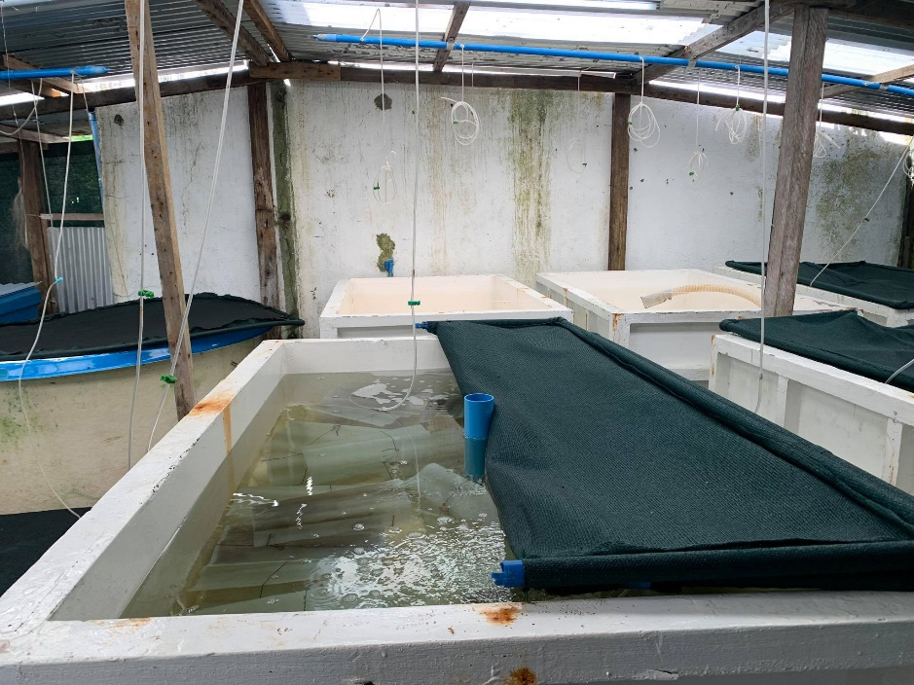
3. Results
3.1 Different seaweed diets
The performance of L. papillosa as feeds for H. scabra juveniles was consistently and significantly highest in terms of growth and survival rates in all experimental runs conducted from February to October 2017. These results are presented in Table 1 and Figure 3.
3.1.1 Growth performance
The mean total weight gain of sea cucumbers fed with L. papillosa ranged from 270.5 mg to 616.7 mg. For the same feed treatment, the average daily growth rate (ADGR) and specific growth rate (SGR) ranged between 6.0–3.7 mg.d⁻¹ and 7.6–11.3%.d⁻¹, respectively. On the other hand, juveniles fed with G. bailinae extract were stunted and had a poor growth performance. In this treatment, juveniles had a mean total weight gain ranging from 38.4 mg to 195.0 mg, ADGR of 0.9–4.3 mg.d⁻¹, and SGR of 3.5–5.1%.d⁻¹. The growth performance of juveniles fed with Sargassum spp. extract was not significantly different from that of the yield of L. papillosa, particularly during experiments conducted in February–March 2017 and September–October 2017.
3.1.2 Survivorship
The highest mean survival rates of sea cucumber juveniles were achieved by feeding L. papillosa extract (54.6–56.8%). Sargassum spp. also yielded mean survival rates, which did not significantly differ from the results of L. papillosa, except during the May–June 2017 experiment. On the other hand, G. bailinae feed extract yielded the lowest mean survival rates ranging from 8.8% to 19.8% in all experimental runs.
3.1.3 Effect of the interaction of seaweed types and rearing schedules
Table 2 shows the summary of the two-factor MANOVA. The analysis shows that there was no statistically significant interaction effect between seaweed treatment and rearing schedule on the combined dependent variables, F (8, 34) = 0.960; p = 0.483, Wilks’ Λ = 0.666. Nevertheless, the results on simple main effects follow the previous findings that the collective results, namely growth and survival rates, were independently affected by varying seaweed types (p < 0.001); and, similarly, affected by varying rearing schedules (p < 0.001). The latter result further implies that the yields of sea cucumber juveniles were different among rearing schedules, regardless of seaweed feed treatment.
3.2 Fresh and dried seaweed diets
The results demonstrated that the performance of dried and fresh seaweed extracts as feeds for sea cucumber juveniles was similar. The experimental runs were conducted in April–May and July–August 2017. Growth rates are shown in Tables 3 and 4, while survival rates are illustrated in Figures 4 and 5.
3.2.1 Growth performance
The growth increment and growth rates of sea cucumber juveniles were not significantly different when fed with fresh or dried seaweed extract. This was concluded after running an independent sample t-test for both seaweeds L. papillosa and Sargassum spp. Consistent findings on growth performance were observed in April–May 2017 and July–August 2017. The results are shown in Table 3 and Table 4.
3.2.2 Survivorship
The experiment also showed no significant difference in the survival rate of juveniles fed with fresh and dried seaweeds. For this experiment, maximum average survival rates were achieved in July–August 2017. L. papillosa fresh extract yielded a mean of 60.0 ± 16.5% survival rate for juveniles with no significant difference against dried L. papillosa with 55.7 ± 11.0% (t = 0.378, p > 0.5). The mean survival rates obtained from using Sargassum spp. fresh extract as feeds were 22.3 ± 7.3% and 39.7 ± 9.9% for April–May and July–August 2017 runs, respectively. These yields were not statistically different (p > 0.05) from using dried Sargassum spp. extract with mean survival rates of 21.0 ± 35.5% and 37.7 ± 9.9%, correspondingly, for the two runs conducted in 2017.
3.2.3 Effect of the interaction of fresh and dried seaweed treatments and rearing schedules
Results show that there was no significant interaction effect of seaweed treatments (fresh and dried) and rearing schedule on the combined dependent variables—growth and survival rate (F (9, 34.223) = 0.540; p = 0.835, Wilks’ Λ = 0.724). In addition, the simple main effect of the seaweed diet was not significant towards growth and survival rates of sea cucumber juveniles (p = 0.769), while notably, there was significance in the main effect of the rearing schedule on growth and survival rates (Table 5). The latter result further implies that the performance of juveniles was better in July-August 2017 than in April–May 2017, regardless of seaweed feed type.
3.3 Different seaweed feed rations
3.3.1 Growth performance
During the experiment conducted in June–July 2017, H. scabra juveniles fed at varying rations of Sargassum sp. extract showed significantly different growths in terms of TWG, ADGR, and SGR (Table 6). Post hoc analysis further revealed that the feed ration of 7.5 and 9.0 L.d⁻¹ yielded the highest values of growth rates with significant differences against the two lower feed rations, 4.5 and 6.0 L.d⁻¹ (p < 0.05). However, the experimental run conducted in October–November 2017 did not demonstrate a consistent result as the previous run. During the second run, the different feed rations had no significant difference in terms of the growth performance of juveniles (p > 0.05).
3.3.2 Survivorship
The survivorship of juveniles did not significantly differ across varying feed rations from experimental runs conducted in June and October 2017. The mean survival rates ranged from 17.2% to 18.8% for 4.5 L.d⁻¹, 14.5–24.0% for 6.0 L.d⁻¹, 19.0–25.7% for 7.5 L.d⁻¹, and 18.7–25.3% for 9.0 L.d⁻¹ feed ration. The mean values for survival rates were not significantly different at p > 0.05, as shown in Figure 6.
3.3.3 Effect of the interaction of varying feed rations and rearing schedules
Results showed that there was a statistically significant interaction effect of the two factors, as mentioned earlier, on the growth and survivorship of sea cucumber juveniles (F (9,34.223) = 5.266; p < 0.001, Wilks’ Λ = 0.121). Furthermore, simple main effects of both factors (seaweed diet and schedule) on the combined growth and survival rate variables were also significant. This further implies that the performance of juveniles was different between the two rearing schedules, regardless of feed treatment.
3.4 Water Quality
The water temperature range in tanks was observed at 25.8–31.1°C for the entire duration of various experiments. Water temperature was significantly highest during April, May, and June 2017, with means of 28.8 ± 0.7, 28.6 ± 1.0, and 28.4 ± 0.9 °C, respectively, p < 0.05 (Figure 7). During these months, high survivorship was observed in Experiment 1 (different seaweed types) with a maximum mean of 57% from L. papillosa feed treatment. Similarly, high survival rates from Experiment 2 (fresh and dried seaweed) were also observed from July to August 2017. The coldest water in tanks was observed during February and November 2017, with a mean of 26.6°C. In the November 2017 experiment, survival rates of juveniles were less than 20% in all treatments.
The water salinity was also highest in April, May, and June with 34.7 ± 0.5, 34.8 ±1.0, and 35.1 ± 0.7 ppt, respectively. Salinity started to drop from July to November except for a slight spike in September 2017. The lowest mean salinity was 33.2 ± 1.0 ppt during October 2017. The salinity measurements observed in tanks ranged from 32.2 ppt to 36.3 ppt. Figure 8 shows the trend in water salinity in experimental tanks for nurseries conducted in 2017, with significant differences at p < 0.05.
Dissolved oxygen (DO) concentrations were highest during the wet months, coinciding with periods of observed colder water temperatures. Highest DO was observed during November 2017 with a mean of 8.32 ± 0.5 mg.L-1, followed by March with 8.0 ± 0.6 mg.L-1 and February 2017 with 7.9 ± 0.9 mg.L-1. In contrast, the lowest mean DO was during April 2017 with 6.1 ± 0.5 mg.L-1. The mean values for DO were also significantly different, as shown in Figure 9.
The average pH measurements were almost stable from February to November 2017 with no significant difference (p > 0.05), as shown in Figure 10. The maximum pH measurement was observed at 8.8, while the minimum observed pH was 7.90. The trend in water pH did not follow any pattern of seasonality.
4. Discussion
4.1 On different seaweed types
The biochemical composition of seaweeds used and the physical quality of the seaweed extracts could help elucidate the results of this study. Some studies compared proximate and nutrient content analysis on Laurencia spp., Sargassum spp., and Gracilaria spp. Laurencia spp. have higher carbohydrate (40–80%) and protein (8–11%) content compared to Gracilaria spp (30–40% carbohydrate, 9% protein). However, total fat (7%) and agar content (14–22%) were highest in the species of Gracilaria (Sumile et al. 2015). Sargassum spp. has a similar range of carbohydrate (34%) and protein (8%) content (Arguelles et al. 2019) with that of Laurencia sp., but also high in agar content (10–30%) (Salosso 2019).
Moreover, a more important aspect that affected the results of this study was the physical quality of the crude extract. In this study, the crude extracts of L. papillosa and Sargassum sp. formed visible coagulates, grazeable for sea cucumber juveniles. On the other hand, G. bailinae crude extract formed minimal coagulates, which were inadequate for foraging. This possibly caused starvation of the juveniles and consequently resulted in poor growth and low survivorship of juveniles in the treatment. This became a concern in the experiments which led to the omission of G. bailinae as an experimental feed treatment in the other experiments (fresh versus dried and different feed rations).
Magcanta et al. (2021) also recently reported favorable results on using Sargassum sp. extract as feeds for juvenile H. scabra under laboratory conditions. Sargassum sp. extract resulted in a high growth rate, survival rate, and feces production rate of juvenile sea cucumbers.
Another aspect that warrants further investigation is the preparation method of the seaweed diet used in feeding sea cucumbers. In some studies, various methods for the preparation and supplementation of seaweeds were applied to feed sea cucumbers grown in nursery tanks. For example, Mahmoud et al. (2017) administered dried and pulverized seaweeds for H. impatiens; Anisuzzaman et al. (2017) combined seaweeds with wheat flour to form paste-like feeds for A. japonicus; Hai-Bo et al. (2015) utilized a mixture of the seaweed Sargassum sp. with corn and soybean meals which were administered at different proportions for Apostichopus japonicus; and, Xia et al. (2012) used a blend of powdered seaweeds and sea mud as feeds for A. japonicus. The methods mentioned above of feed preparation generally demonstrated mixing seaweeds with other components, which supplemented the seaweeds and made them suitable for grazing animals. These were not applied in the present study to maintain the simplicity of seaweed preparation and due to economic reasons. Nonetheless, the study results showed the feasibility of seaweed crude extracts as feeds for H. scabra juveniles grown in indoor nursery tanks.
4.2 On fresh and dried seaweed diets
This experiment was conducted to determine the feasibility of dried seaweeds as feeds for juveniles. The differences in growth performance and survival rates of juveniles fed with fresh and dried seaweeds were not statistically significant. This broadly demonstrated that the performance of fresh seaweeds was similar to the dried ones. This aspect of the research suggests that the dried seaweed diets can also substitute fresh seaweed diets for sea cucumber juveniles grown in a nursery tank system.
Freshly harvested seaweeds are conventionally the source of nourishment of H. scabra juveniles and other commodities reared in tank-based systems at the BFAR-GMFDC hatchery. However, wet seaweeds require additional tanks for storage and will eventually deteriorate in a few weeks when not used. Drying the seaweeds will help prevent spoilage and be cost-efficient since they can be stored for longer periods without substantial loss in their nutrients (Chan et al. 1997). In this study, sun-drying was preferred since the method is simple and economical and can easily be duplicated by small-scale sea cucumber growers.
4.3 On different feed rations
The findings on the growth performance of juveniles in varying treatments demonstrated similar results in 7.5 and 9.0 L.d⁻¹ feed rations, which both showed superior performance than both 4.5 and 6.0 L.d⁻¹ feed rations. However, contrary to the outcomes on growth performance of juveniles, there was no substantial difference in survival rates of juveniles fed at different feeding rations. This at least hinted that the minimum feeding ration (4.5 L.d-¹) provided a good quantity of juveniles comparable to that of the produce of the higher feeding ration. Nevertheless, the quality of seeds was compromised by slow growth rates and stunted sizes when fed at minimal volume.
The experiment yet suffers from the limitation of determining the ingestion rate of juveniles and digestibility of the seaweed diets at different feeding rations. This approach would have further illustrated the possible effect of increasing or decreasing feeding amounts on the performance of sea cucumber juveniles. Despite that, it was observable that high feeding frequency was associated with a high accumulation of seaweed extract, implying less starvation and better growth for the animals. Each tank had a flow-through system, and excess seaweeds and animal feces were regularly siphoned out to prevent fouling which could affect the study results.
4.4 On seasonality and water quality
The three different experiments on seaweed regimens were run in different schedules of the year to determine further whether seasonality affects the rearing of sea cucumbers. Results of the main effects through MANOVA show that the combined variables of growth performance and survivorship of juveniles were affected by varying rearing schedules in all three experiments. Furthermore, it was observed that the performance of juveniles was better during the dry months than in wet months. Experiments conducted during May–June 2017 had one of the highest mean survival rates, up to 58%. On the other hand, during the experiment conducted in October–November 2017 lowest survival rates were recorded with less than 20% in all setups. From water quality monitoring, it can be noted that warmer water was observed in tanks from April to June 2017, while colder water was observed in February–March and October–November, both coinciding with the dry and wet seasons in the Philippines, respectively. Early juveniles harvested from hatchery tanks also had stunted growth (mean of ~1.8 mg, see Table 1) from September to October 2017. Moreover, results during this period also have shown the poorest growth performance and survivorship of juveniles, among different rearing schedules.
Variable seasonality also led to fluctuations in water quality, specifically temperature and salinity. This study observed that during the rainy season, when excessive precipitation and significant weather disturbances such as typhoons and low-pressure areas (LPAs) afflicted Eastern Samar, the growth and survival of juvenile sea cucumbers were often poor. Fluctuations in water quality were possible despite being in indoor tanks since the water supply came from the sea near the hatchery. This case was also similar to the performance of first-phase juveniles grown in open-ocean nurseries observed in a separate study by Cabacaba and Campo (2019) and to the reports of Juinio-Meñez et al. (2012) and Gamboa et al. (2012).
Lower temperatures resulted in negative growth rates for the sea cucumbers grown in aquaria (Günay et al. 2015); however, extreme temperatures caused higher mortality of juveniles (Seeruttun et al. 2008). The salinity of seawater used for rearing was affected by the changing weather in Eastern Samar. During wet months, high precipitation caused water salinity to drop slightly compared to salinities recorded during the dry months. The decline in water salinity in tanks could also have negatively affected the growth of sea cucumber juveniles in the tanks. Seeruttun et al. (2008) reported disrupted growth and low survivorship of juvenile H. atra in salinities lower than 30 ppt.
Water quality, particularly temperature, may also be an important factor related to the feeding behavior of juvenile sea cucumbers (Lavitra et al. 2010). Sea cucumber juveniles tend to be inactive in feeding and burrow into sediments for a longer duration when the temperature decreases (Purcel and Kirby 2005). Warmer water induced juveniles to change the burying cycle and remain on the surface of the sediment (Mercier et al. 1999). Also, the abundance of benthic phytoplankton, food for the juveniles, increases during warmer seasons (Pitt and Duy 2004). During the experiment conducted in April 2017, the invasive macroalgae Cladophora spp. and thick algae biofilm rapidly occupied the tanks. Some juveniles were entangled by the filamentous algae, which could have affected their movement and, consequently, their feeding. However, this did not significantly affect the survival rates of juveniles as removal of unwanted algae and regular cleaning of the tanks were promptly done to prevent further infestation.
Although some insights on seasonality have been provided, the influence of water quality on the growth and survival of sea cucumber juveniles was not clearly established in this study. The growth and survival rates of sea cucumber juveniles were not always consistent. For example, regardless of feed type, the high yield in the cold months of September to October did
4.5 On growth performance and survivorship
The growth of H. scabra juveniles was observed to be highly heterogeneous in all experiments. Cohorts of sea cucumber juveniles in a particular treatment could grow larger than 1000 mg (>3 cm in body length) or even as stunted as 100 mg (<1 cm) at the end of the rearing. Also, better growth performance of a particular treatment did not always result in better survivorship. In some cases of experimentation, the growth of juveniles was poor yet had a similar survival rate to other treatments. Hence, multi-factor multivariate ANOVA was a critical tool to analyze all variables, collectively through interaction effects and independently through simple main effects. Nevertheless, survivorship should be the primary criteria in assessing the success of seed production as growth performance can be improved through supplementation and increment in feeding.
4.6 Advantages and disadvantages of indoor tank systems
The sea cucumber hatchery of BFAR-GMFDC has not yet religiously practiced juvenile rearing in tanks since juveniles are distributed to local farmers and are transferred to enhancement areas in Eastern Samar. Indoor tanks with seaweed supplements are only being utilized for further rearing when seeds from larval production do not satisfy the expected size after a month (>1 mm). Traditionally, one-month-old juveniles are directly released in floating hapa net cages in the open sea until they reach the release size of 3-5 g for grow-out. Although this method is promisingly economical, survival in hapa nets is uncertain due to predation by some invading organisms such as crabs and fishes and the vulnerability of juveniles to uncontrolled environmental factors such as fluctuating temperature and salinity. Such problems in outdoor floating net cages could yield lower survival of juveniles compared to the rearing of juveniles in tanks fed with seaweeds. Cabacaba and Campo (2019) have reported better survival rates of juveniles reared in indoor tanks than in outdoor floating net cages. Moreover, ocean nursery systems are preferable in overcoming space limitations in land-based setup (Juinio-Meñez et al. 2012) and overhead costs such as feeds, aeration, and water supply systems. However, nursery production in a tank system may be the best option during wet seasons when typhoons, heavy precipitation, and strong currents result in physical damage to the ocean nurseries, high mortality, and low juvenile recovery. In hatcheries with sufficient capital outlay, large-scale production of sea cucumbers in a tank-based system that uses dried seaweeds may be a feasible rearing option throughout the year.
5. Conclusion
The feasibility of nursery rearing in indoor tanks for the juvenile sea cucumber H. scabra with the utilization of locally-available seaweeds is provided in this research. Various experiments were conducted evaluating Laurencia papillosa, Gracilaria bailinae, and Sargassum sp. as seaweed feed, comparing fresh and dried seaweed diets and determining the optimum feeding ration of seaweed diet.
The growth performance and survivorship of juveniles fed with L. papillosa and Sargassum sp. were favorable but not when fed with G. bailinae. An important aspect observed in this experiment was the formation of extract coagulates manifested by crude extracts of L. papillosa and Sargassum sp. In contrast, fewer coagulates were produced from G. bailinae, which resulted in starvation and eventually poor growth and low survival of juveniles. This experiment suggests the utilization of seaweeds as an alternative or supplementary nourishment for sea cucumbers in tank-based nurseries. However, cultured or farmed seaweeds are commercially valuable. For this reason, we recommend using the stray seaweeds only.
Dried seaweeds performed well in terms of the growth and survivorship of sea cucumber juveniles, similar to fresh seaweed extract. Therefore, seaweeds can also be prepared for drying and stored for future use as feeds without affecting the growth and survival of juvenile sea cucumbers. This study aspect gives insight into the potential economic benefits of storing seaweeds in terms of cost-efficiency.
Findings of the experiment on varying feed rations also revealed that the minimum feeding ration of 4.5 L/day of seaweed extract dilution was a sufficient amount in feeding sea cucumber juveniles.
Several facets of the seaweed diet regimen were not considered or measured in this study, such as the method and preparation of seaweed diets, digestibility of seaweeds, and estimation of ingestion rates, among others. These components warrant future investigation.
Moreover, aspects of seasonality and water quality in rearing tanks also provided guidance for future application in experimental or large-scale production. The dry season or the warm months provided better yields of sea cucumber juveniles compared to the wet season or cold months. Sea cucumber juveniles reared in a tank-based system are also not at risk from abrupt fluctuations or sub-optimal level occurrence in water quality, especially during an extreme weather disturbance.
There are several hatcheries for sea cucumber in the Philippines, including BFAR-GMFDC in Eastern Visayas, SEAFDEC–AQD in Iloilo, Western Visayas, and UP MSI in Pangasinan, Central Luzon. These institutions have also taken part in re-establishing the sea cucumber resource in the country through research, development, and community partnerships. As such, these regions and their nearby areas are also prospects for sea cucumber large-scale production.

Acknowledgment
The authors would like to acknowledge the technical and financial support of the National Fisheries Research and Development Institute, as well as the assistance rendered by Mr. Roy Francis M. Abuda, Ms. Alicia O. Lacdo-o, and Mr. Michael S. Gayoso during the conduct of the sea cucumber nursery experiments.

Author Contributions (Just insert here the CRediT author statement you provided in the cover letter)

Conflicts of Interest (Even if there is no conflict of interest, you still need to explicitly mention it here.)

Ethics Statement (Please refer to our Guide for Authors and Publication Policy)
References
Agudo NS. 2006. Sandfish hatchery techniques. Australian Centre for International Agricultural Research, Secretariat of the Pacific Community, and WorldFish Center. Australia. 44 p.
Anisuzzaman MD, U-Cheol J, Feng J, Jong-Kuk C, Kamrunnahar K, Da-In L, Hak Sun Y, Seok Joong K. 2017. Effects of different algae in diet on growth and interleukin (IL)-10 production of juvenile sea cucumber Apostichopus japonicus. Fisheries and Aquatic Sciences. 20:24. https://doi.org/10.1186/s41240-017-0069-5
Arguelles EDLR, Monsalud RG, Sapin AB. 2019. Chemical Composition and In Vitro Antioxidant and Antibacterial Activities of Sargassum vulgare C. Agardh from Lobo, Batangas, Philippines. The Journal of the International Society for Southeast Asian Sciences. 21(1):112-122.
Cabacaba NS, Campo CJM. 2019. First-phase juvenile rearing of the sea cucumber Holothuria scabra in Eastern Samar, Philippines. The Philippine Journal of Fisheries.26(2):72–81. https://doi.org/10.31398/tpjf/26.2.2019A0009
Campo CJM, Cabacaba NS, Cosmiano DNJ. 2019. Growth, development and survival of Holothuria scabra larvae in different microalgal regimens and water rearing media. The Philippine Journal of Fisheries. 26(2):33-45. https://doi.org/10.31398/tpjf/26.2.2019A0003
Chan JCC, Cheung PCK, Ang PO. 1997. Comparative Studies on the Effect of Three Drying Methods on the Nutritional Composition of Seaweed Sargassum hemiphyllum (Turn.) C. Ag. J Agric Food Chem. 45(8):3056−3059. https://doi.org/10.1021/jf9701749
Choo PS. 2008. The Philippines: a hotspot of sea cucumber fisheries in Asia. In: Vasconcellos V, Lovatelli A, Vasconcellos M, editors. Sea cucumbers. A global review of fisheries and trade. FAO Fisheries and Aquaculture Technical Paper No. 516. Rome: FAO. pp. 119-140.
Gamboa R, Juinio-Meñez MA. 2003. Pilot-testing the hatchery production of the sea cucumber, Holothuria scabra (Jaeger) in the Philippines. The Philippine Scientist. 40:111-121.
Gamboa R, Gomez AL, Nievales MF. 2004. The status of sea cucumber fishery and mariculture in the Philippines. In: Conand C, Purcell S, Uthicke S, Hamel JF, Mercier A. editors. Advances in Sea Cucumber Aquaculture and Management. FAO Fisheries Technical Paper 463. Rome: FAO. pp. 69-78.
Gamboa RU, Aurelio RA, Ganad DA, Concepcion LB, Abreo NAS. 2012. Small-scale hatcheries and simple technologies for sandfish (Holothuria scabra) production. In: Hair CA, Pickering TD, Mills DJ, editors. Asia Pacific tropical sea cucumber aquaculture. ACIAR Proceedings No. 136, 63–74. Canberra: Australian Centre for International Agricultural Research.
Günay D, Emiroğlu D, Tolon T, Özden O, Saygi H. 2015. Growth and Survival Rate of Juvenile Sea Cucumbers (Holothuria tubulosa, Gmelin, 1788) at Various Temperatures. Turkish Journal of Fisheries and Aquatic Sciences. 15:533-541. https://doi.org/10.4194/1303-2712-v15_2_41
Hai-Bo Y, Qin-Feng G, Shuang-Lin D, Bin W. 2015. Changes in fatty acid profiles of sea cucumber Apostichopus japonicus (Selenka) induced by terrestrial plants in diets. Aquaculture. 442:119–24. https://doi.org/10.1016/j.aquaculture.2015.03.002
Hamel JF, Mercier A, Conand C, Purcell S, Toral-Granda T, Gamboa R. 2013. Holothuria scabra. The IUCN Red List of Threatened Species. e.T180257A1606648. https://dx.doi.org/10.2305/IUCN.UK.2013-1.RLTS.T180257A1606648.en
Juinio-Meñez MA, de Peralta GM, Dumalan RJP, Edullantes CMA and Catbagan, TO. 2012. Ocean nursery systems for scaling up juvenile sandfish (Holothuria scabra) production: ensuring opportunities for small fishers. In: Hair CA, Pickering TD, Mills D.J, editors. Asia–Pacific tropical sea cucumber aquaculture. Proceedings of an international symposium held in Noumea, New Caledonia, 15–17 February 2011. ACIAR Proceedings No. 136. Canberra: Australian Centre for International Agricultural Research. 209 p.
Lavitra T, Fohy N. Gestin P-G, Rasolofonirina R, Eeckhaut I. 2010. Effect of water temperature on the survival and growth of endobenthic Holothuria scabra (Echinodermata: Holothuroidea) juveniles reared in outdoor ponds. SPC Beche-de-mer Information Bulletin #30:25-28
Magcanta MLM, Sornito MB, Espadero ADA, Bacosa HP, Uy WH. 2021. Growth, Survival, and Behavior of Early Juvenile Sandfish Holothuria scabra (Jaeger, 1883) in Response to Feed Types and Salinity Levels under Laboratory Conditions. Philippine Journal of Science.150(5):871-884.
Mahmoud MAM, El-Saman MI, Ali Babeker E. 2017. Effects of Different Macroalgae diets on Growth Performance on Impatient Sea Cucumber Holothuria impatiens Forskaal, 1775 (Echinodermata: Holothuroidea. Journal of Fisheries and Aquatic Science. 12(4):177-183. https://doi.org/10.3923/jfas.2017.177.183
Marinho-Soriano E, Fonseca PC, Carneiro MAA, Moreira WSC. 2006. Seasonal variation in the chemical composition of two tropical seaweeds. Bioresource Technology. 97(18):2402-2406. https://doi.org/10.1016/j.biortech.2005.10.014
Mercier A, Battaglene SC, Hamel JF. 1999. Daily burrowing cycle and feeding activity of juvenile sea cucumbers Holothuria scabra in response to environmental factors. Journal of Experimental Marine Biology and Ecology. 239(1):125–156. https://doi.org/10.1016/S0022-0981(99)00034-9
Pitt R, Duy NDQ. 2004. Breeding and rearing of the sea cucumber Holothuria scabra in Vietnam. p. 333–346. In: Lovatelli A, Conand C, Purcell S, Uthicke S, Hamel JF, Mercier A, editors. Advances in sea cucumber aquaculture and management. Fisheries Technical Paper No. 463. Rome: FAO. https://hdl.handle.net/20.500.12348/2069
Purcell SW, Kirby DS. 2005. Restocking the sea cucumber Holothuria scabra: Sizing no-take zones through individual-based movement modelling. Fisheries Research. 80(1):53–61. https://doi.org/10.1016/j.fishres.2006.03.020
Rajauria G. 2015. Chapter 15 - Seaweeds: a sustainable feed source for livestock and aquaculture. In: Tiwari BK, Troy DJ, editors. Seaweed Sustainability: Food and Non-Food Application. 389-420. https://doi.org/10.1016/B978-0-12-418697-2.00015-5
Salosso Y. 2019. Nutrient and alginate content of macroalgae Sargassum sp. from Kupang Bay waters, East Nusa Tenggara, Indonesia. AACL Bioflux. 12(6):2130-2136.
[SEAFDEC-AQD] Southeast Asian Fisheries Development Center - Aquaculture Department. 2018. Sea cucumber hatchery and nursery production. [Brochure]. Tigbauan, Iloilo, Philippines. http://hdl.handle.net/10862/3431
Seeruttun R, Appadoo C, Laxminarayana A, Codabaccus B. 2008. A Study on the Factors Influencing the Growth and Survival of Juvenile Sea Cucumber, Holothuria atra, under Laboratory Conditions. University of Mauritius Research Journal. 14(1):15.
Sumile KC, Orbita MLS, Mag-aso AV, Orbita RR. 2015. Proximatefarge composition and agar content of selected red seaweeds in Initao, Misamis Oriental, Mindanao, Philippines. AAB Bioflux. 7(2):115-121.
Tolon T, Emiroglu D, Gunay D, Hanci B. 2016. Effect of stocking density on growth performance of juvenile sea cucumber Holothuria tubulosa (Gmelin, 1788). Aquaculture Research. 48(8):4124-4131. https://doi.org/10.1111/are.13232
Uthicke S. 2004. Overfishing of holothurians: lessons from the Great Barrier Reef. In: Lovatelli A, Conand C, S. Purcell S, Uthicke S, Hamel JF, Mercier A, editors. Advances in sea cucumber aquaculture and management. Rome: FAO.
Xia S, Zhao P, Chen K, Li Y, Liu S, Zhang L, Yang H. 2012. Feeding preferences of the sea cucumber Apostichopus japonicus (Selenka) on various seaweed diets. Aquaculture. 344-349: 205–209. https://doi.org/10.1016/j.aquaculture.2012.03.022

Tables

Table 1. Mean initial body weight (IBW), total weight gain (TWG), average daily growth rate (ADGR), and specific growth rate (SGR) of H. scabra juveniles fed with different seaweed diets.
Rearing Schedule | Seaweed diet | Initial Body Weight  (mg) | Total Weight Gain (mg) | Average daily growth rate  (mg.d⁻¹) | Specific growth rate (%.d⁻¹)
Feb–Mar 2017 | L. papillosa | 25.0 ± 2.0ª | 616.7 ± 176.2 ª | 13.7 ± 3.9 ª | 7.6 ± 0.7 ª
 | Sargassum sp. | 25.0 ± 5.0ª | 655.0 ± 115.0 ª | 14.6 ± 2.6 ª | 7.8 ± 0.4 ª
 | G. bailinae | 25.0 ± 4.0ª | 195.0 ± 101.1 ^{b} | 4.3 ± 2.3 ^{b} | 5.1 ± 1.3 ^{b}
 | F-value | 9.011 | 10.761 | 10.761 | 9.477
 | p-value | >0.05 | <0.05 | <0.05 | <0.05
May–Jun 2017 | L. papillosa | 20.6 ± 1.0ª | 494.0 ± 184.7 ª | 11.0 ± 4.1 ª | 6.3 ± 0.2 ª
 | Sargassum sp. | 20.3 ± 1.2ª | 181.0 ± 73.8 ^{b} | 4.0 ± 1.6 ^{b} | 5.0 ± 0.9 ^{b}
 | G. bailinae | 20.3 ± 1.0ª | 38.4 ± 9.3 ^{b} | 0.9 ± 0.2 ^{b} | 3.5 ± 0.4 ^{c}
 | F- value | 0.30 | 12.238 | 12.239 | 17.253
 | p-value | >0.05 | <0.01 | <0.01 | <0.01
Sept–Oct 2017 | L. papillosa | 1.7 ± 0.6ª | 270.5 ± 12.1 ª | 6.0 ± 0.3 ª | 11.3 ± 0.8 ª
 | Sargassum sp. | 1.7 ± 0.4ª | 243.8 ± 64.3 ª | 5.4 ± 1.4 ª | 11.0 ± 0.7 ª
 | G. bailinae | 1.9 ± 0.3ª | 147.6 ± 101.8 ª | 3.3 ± 2.3 ª | 9.4 ± 1.5 ª
 | F- value | 0.21 | 2.568 | 2.568 | 2.835
 | p-value | >0.05 | >0.05 | >0.05 | >0.05
Note: Mean (± SD; n = 3) values with different letters across seaweed treatments show significant differences using single-factor ANOVA at p<0.05 via the Duncan post hoc test.

Table 2. Two-factor MANOVA table for the interaction effect of different seaweed feeds and rearing schedules on the combined dependent variables (growth rates and survival rates) using Wilk’s Lamda multivariate test statistic.

Effect | Wilk's Lambda Value | F | Hypothesis df | Error  df | p-value
Intercept | 0.007 | 1181.733 | 2 | 17 | <0.001
Seaweed Diet | 0.117 | 16.348 | 4 | 34 | <0.001
Schedule | 0.072 | 23.082 | 4 | 34 | <0.001
Seaweed Diet * Schedule | 0.666 | 0.960 | 8 | 34 | 0.483

Table 3. Descriptive statistics and independent sample t-test results for the growth performance (total weight gain, average daily growth rate, and specific growth rate) of juveniles fed with fresh and dried L. papillosa.
 |  | Groups |  | Mean Difference (95% CI) | T | df | p-value
 |  | Fresh  L. papillosa  (mean ± SD) | Dried  L. papillosa  (mean ± SD)
April-May 2017 | IBW (mg) | 14.8 ± 3.2 | 14.3 ± 3.1 | 0.00 | 0.204 | 4 | 0.857
 | TWG (mg) | 274.2 ± 23.7 | 179.9 ± 90.5 | 94.30 | 1.030 | 4 | 0.361
 | ADGR (mg.d⁻¹) | 6.1 ± 0.3 | 4.0 ± 2.0 | 2.10 | 1.030 | 4 | 0.361
 | SGR (%.d⁻¹) | 6.6 ± 0.3 | 4.7 ± 2.3 | 1.94 | 0.824 | 4 | 0.456
July-August 2017 | IBW (mg) | 21.0 ± 3.0 | 20.0 ± 5.2 | 0.10 | 0.434 | 4 | 0.165
 | TWG (mg) | 389.33 ± 72.50 | 290.0 ± 63.8 | 99.333 | 1.781 | 4 | 0.149
 | ADGR (mg.d⁻¹) | 8.65 ± 1.61 | 6.4 ± 1.4 | 2.207 | 1.781 | 4 | 0.149
 | SGR (%.d⁻¹) | 8.17 ± 0.39 | 7.5 ± 0.5 | 0.647 | 1.856 | 4 | 0.137
Note: Mean (± SD; n = 3) values show significant differences using independent sample T-test at p < 0.05.

Table 4. Descriptive statistics and independent sample t-test results for total weight gain, average daily growth rate, and specific growth rate of juveniles fed with fresh and dried Sargassum sp.
 |  | Groups |  | Mean Difference (95% CI) | t | df | p-value
 |  | Fresh  Sargassum sp.  (mean ± SD) | Dried  Sargassum sp.  (mean ± SD)
April-May 2017 | IBW (mg) | 19.7 ± 5.5 | 14.0 ± 3.0 | 0.09 | 2.644 | 4 | 0.118
 | TWG (mg) | 347.0 ± 240.5 | 220.1 ± 228.5 | 126.870 | 0.662 | 4 | 0.544
 | ADGR (mg.d⁻¹) | 7.7 ± 5.3 | 4.9 ± 5.1 | 2.819 | 0.662 | 4 | 0.544
 | SGR (%.d⁻¹) | 6.3 ± 0.8 | 4.5 ± 4.1 | 1.730 | 0.725 | 4 | 0.509
July-August 2017 | IBW (mg) | 20.0 ± 0.6 | 20.0 ± 1.0 | 0.02 | 3.059 | 4 | 0.762
 | TWG (mg) | 413.3 ± 110.5 | 360.0 ± 52.9 | 53.333 | 0.756 | 4 | 0.492
 | ADGR (mg.d⁻¹) | 9.2 ± 2.5 | 8.0 ± 1.2 | 1.185 | 0.756 | 4 | 0.492
 | SGR (%.d⁻¹) | 8.3 ±0.6 | 8.0 ± 0.3 | 0.270 | 0.727 | 4 | 0.508
Note: Mean (± SD; n = 3) values show significant differences using independent sample T-test at p<0.05.

Table 5. Two-factor MANOVA table for the interaction effect of fresh and dried seaweeds and rearing schedule on the combined dependent variables (growth rates and survival rates) using Wilk’s Lamda multivariate test statistic.
Effect | Wilk's Lambda Value | F | Hypothesis df | Error  df | p-value
Intercept | 0.057 | 77.444 | 3 | 14.000 | <0.001
Fresh and Dried Seaweed Diet | 0.691 | 0.623 | 9 | 34.223 | 0.769
Schedule | 0.492 | 4.819 | 3 | 14.000 | 0.017
Fresh and Dried Seaweed Diet * Schedule | 0.724 | 0.540 | 9 | 34.223 | 0.835

Table 6. Mean (± SD) total weight gain, average daily growth rate, and specific growth rate of H. scabra juveniles fed with Sargassum sp. at different feeding quantities

 | Seaweed Feed Quantity |  | Initial Body Weight  (mg) | Total Weight Gain (mg) | Average daily growth rate  (mg.d⁻¹) | Specific growth rate (%.d⁻¹)
Jun – Jul 2017 | 4.5 L.d⁻¹ |  | 12.50 ± 1.00 ª | 8.08 ± 1.08 ^{b} | 10.04 ± 0.62 ^{b} | 10.04 ± 0.62 ^{b}
 | 6.0 L.d⁻¹ |  | 13.00 ± 0.46 ª | 220.09 ± 12.54 ^{b} | 7.33 ± 0.42 ^{b} | 9.62 ± 0.25 ^{b}
 | 7.5 L.d⁻¹ |  | 13.17 ± 0.58 ª | 410.14 ± 34.85 ª | 13.67 ± 1.16 ª | 11.56 ± 0.31 ª
 | 9.0 L.d⁻¹ |  | 13.00 ± 0.87 ª | 422.39 ± 57.31 ª | 14.07 ± 1.91 ª | 11.69 ± 0.66 ª
 | F-value |  | 0.436 | 24.182 | 24.182 | 13.495
 | p-value |  | >0.05 | <0.001 | <0.001 | 0.002
Oct–Nov 2017 | 4.5 L.d⁻¹ |  | 17.00 ± 0.6 ª | 141.61 ± 43.10 ª | 4.7 ± 1.43 ª | 8.96 ± 1.01 ª
 | 6.0 L.d⁻¹ |  | 16.40 ± 0.22 ª | 143.09 ± 30.43 ª | 4.77 ± 1.01 ª | 9.05 ± 0.68 ª
 | 7.5 L.d⁻¹ |  | 16.90 ± 0.32 ª | 187.05 ± 45.26 ª | 6.23 ± 1.51 ª | 9.87 ± 0.78 ª
 | 9.0 L.d⁻¹ |  | 18.8 ± 0.10ª | 181.89 ± 10.11 ª | 6.06 ± 0.34 ª | 9.84 ± 0.18 ª
 | F- value |  | 0.941 | 1.450 | 1.450 | 1.383
 | p-value |  | >0.05 | >0.05 | >0.05 | >0.05
 |  | Note: Mean (± SD; n = 3) values with different letters show a significant difference at p < 0.05 via the Duncan post hoc test.

Table 7. Two-factor MANOVA table for the interaction effect of different seaweed feed ration and rearing schedule on the combined dependent variables (growth rates and survival rates) using Wilk’s Lamda multivariate test statistic.
Effect | Wilk's Lambda Value | F | Hypothesis df | Error  df | p-value
Intercept | 0.001 | 8413.122 | 3 | 14.000 | <0.001
Seaweed feed ration | 0.046 | 96.022 | 3 | 14.000 | <0.001
Schedule | 0.144 | 4.637 | 9 | 34.223 | <0.001
Seaweed feed ration * Schedule | 0.121 | 5.266 | 9 | 34.223 | <0.001

FIGURES

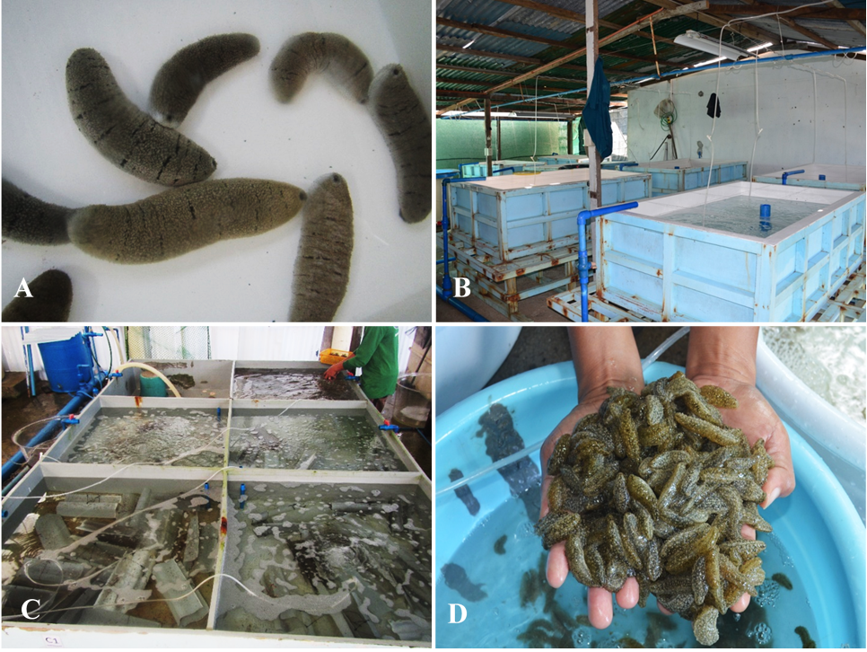

Figure 1. A) Healthy Holothuria scabra broodstock, each weighing more than 250 g; B) Spawning and larval tanks at the sea cucumber hatchery of BFAR-GMFDC in Guiuan, Eastern Samar; C) Indoor nursery rearing tanks for experimentation on various seaweed feed regimen; D) Sea cucumber juveniles fed with Sargassum sp. harvested from an experiment in indoor nursery rearing tanks after 45 days
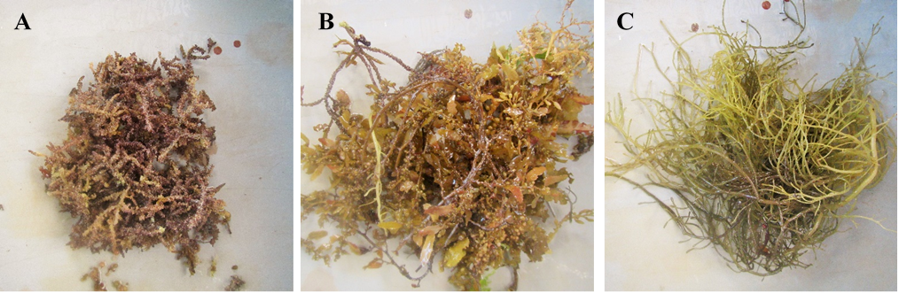

Figure 2. Seaweed diets used in the experiments A) Laurencia papillosa, B) Sargassum sp., C) Gracilaria bailinae.
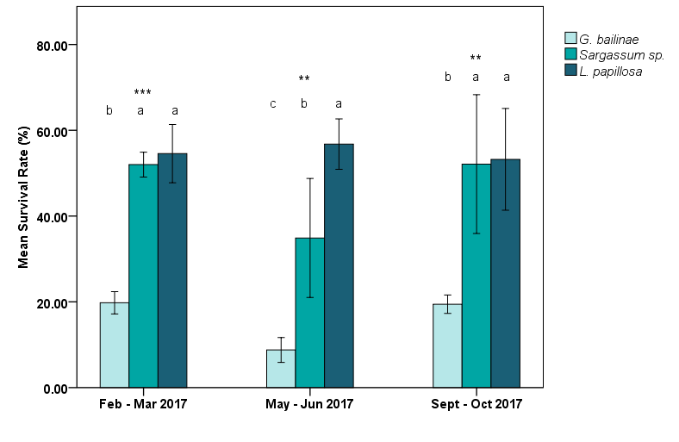

Figure 3. Mean survival rates of H. scabra juveniles fed with L. papillosa, G. bailinae, and Sargassum sp. Note: Survival rates show averaged values from data of the trials performed in February–March, May–June, and September–October 2017. Bars (mean ± SD; n = 3) with different letters show significant differences at **p < 0.01, and ***p < 0.001.

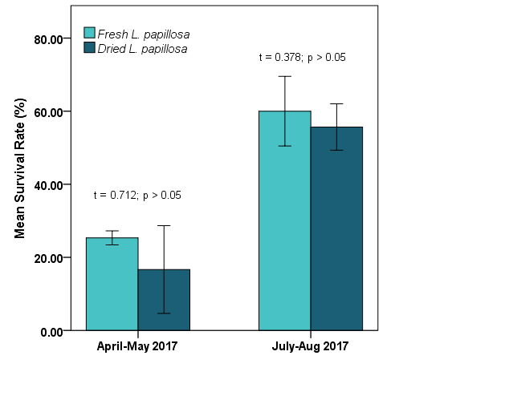
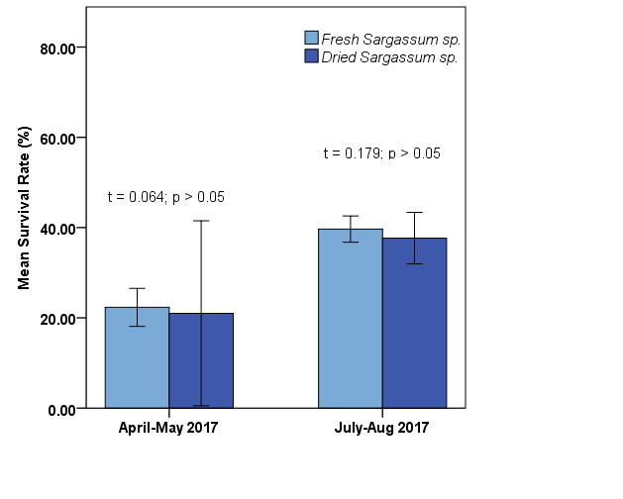

Figure 4-5. Mean survival rates of H. scabra juveniles fed with fresh and dried L. papilllosa and Sargassum sp. Note: Survival rates show averaged values (mean ± SD; n = 3) from data of the trials performed in April–May and July–August 2017.

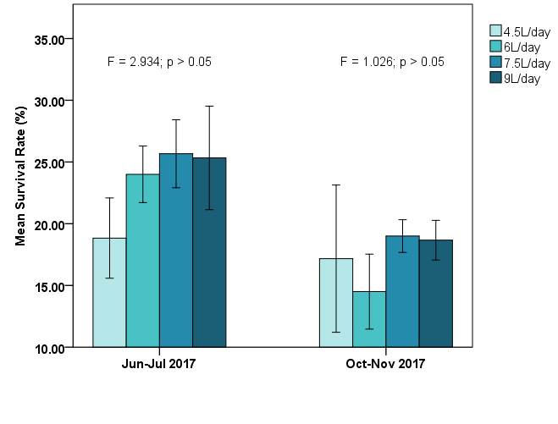

Figure 6. Mean (± SD, n = 3) survival rate of H. scabra juveniles fed with Sargassum sp. at feeding rations 4.5, 6.0, 7.5, and 9.0 L.d⁻¹. Note: Survival rates show averaged values from data of the trials performed in June–July and September–October 2017.
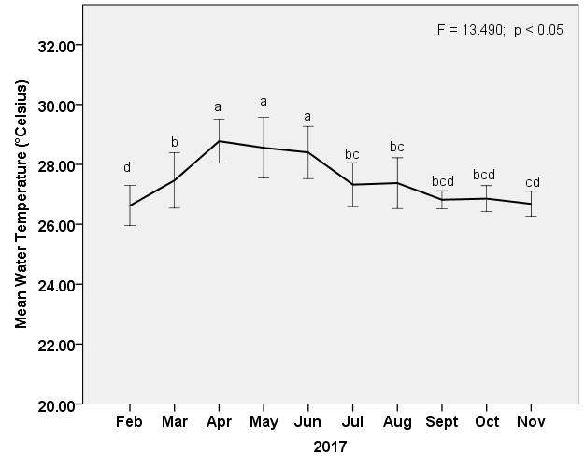

Figure 7. Mean water temperature in indoor rearing tanks of sea cucumber nursery rearing experiments from February to November 2017. Note: Means (± SD, N = 315)) with different labeled letters show a significant difference at p < 0.05 via the Duncan post hoc test.
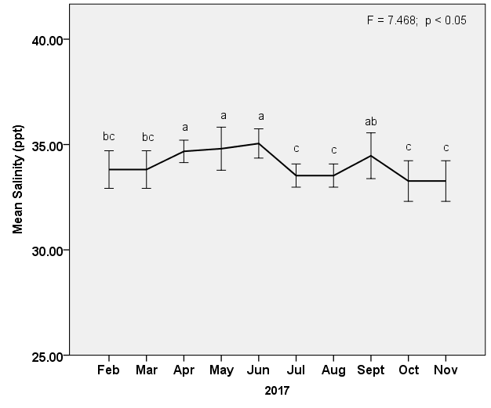

Figure 8. Mean water salinity in indoor rearing tanks of sea cucumber nursery rearing experiments from February to November 2017. Note: Means (± SD, N = 315) with different labeled letters show a significant difference at p < 0.05 via the Duncan post hoc test.

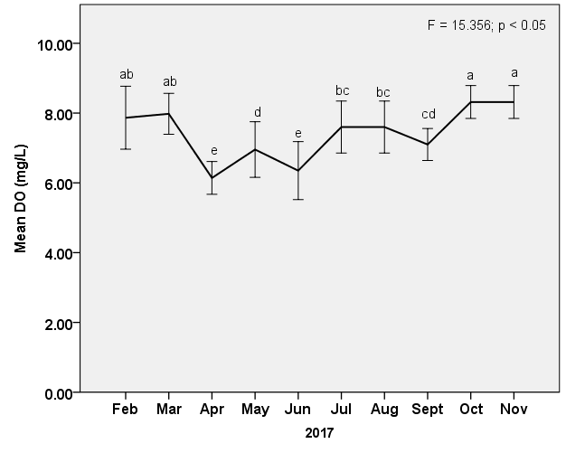

Figure 9. Mean dissolved oxygen of water in indoor rearing tanks of sea cucumber nursery rearing experiments from February to November 2017. Note: Means (± SD, N = 315) with different labeled letters show a significant difference at p < 0.05 via the Duncan post hoc test.
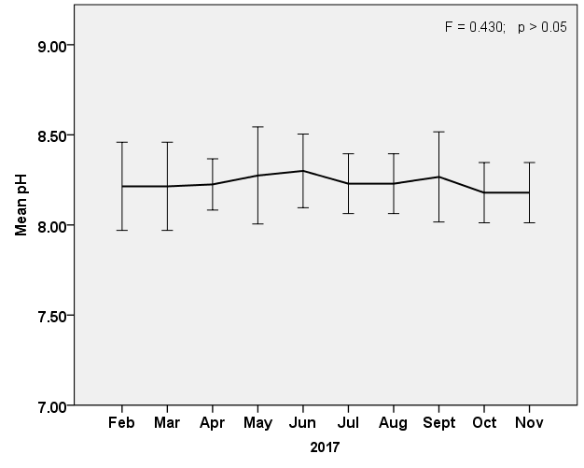

Figure 10. Mean pH of water in indoor rearing tanks of sea cucumber nursery rearing experiments from February to November 2017. Note: Means (± SD, N = 315) with different labeled letters show a significant difference at p < 0.05 via the Duncan post hoc test.

